Simmons-Johnson Family Reunion
July 9th – 12th, 2026
Bay Creek Park
3706 Dock Site Road
Edisto Island,
South Carolina 29438

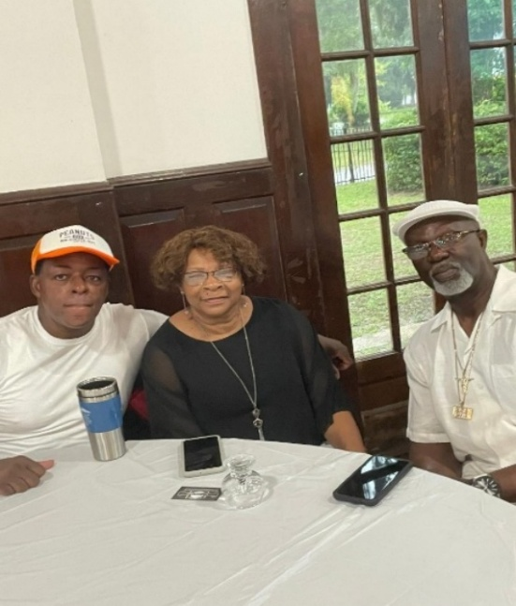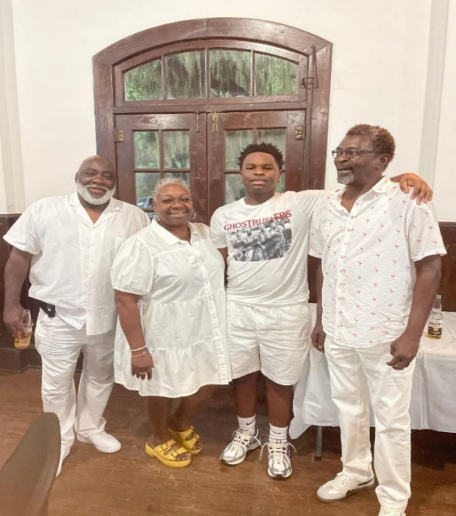

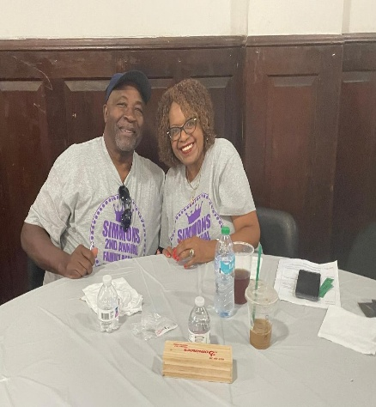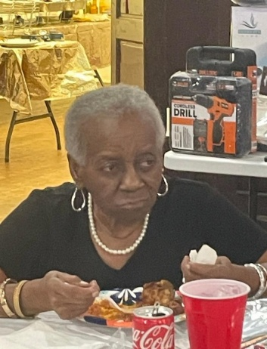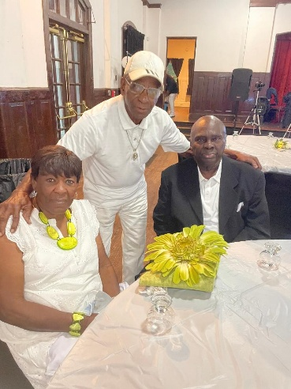

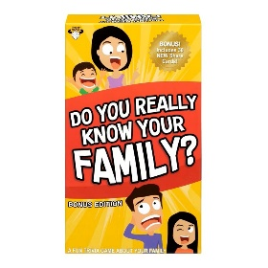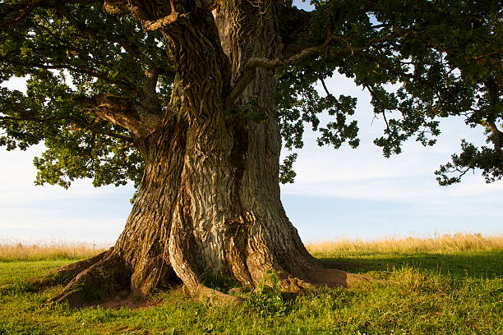

A family reunion is an occasion when many members of an extended family congregate. Sometimes reunions are held regularly, for example on the same date of every year.
A typical family reunion will assemble for a meal, some recreation and discussion. The older attendees are generally grandparents, parents, siblings or first cousins while the youngest may be second, third or fourth cousins to each other, all other can be self-pollinating family members at fifth cousins. It is also not uncommon for regular family reunions to be sponsored by family organizations or family associations centered on a more distant common ancestor (often referred to as "ancestral family organizations") or a commonly shared surname ("single surname family organizations").
Theme: The 70’s
Soul Train Dance Party and Games
Don’t forget your platform shoes, butterfly collar and bellbottoms!!!
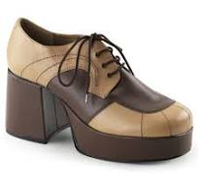
Simmons - Johnson 4th Annual Family Reunion
July 9th - July 12th, 2025
Tentative Itinerary
Bay Creek Park
3706 Dock Site Road
Edisto Island, South Carolina 29438
Point of Contact:
Kenneth Simmons
(443)-679-8759
Kenneth.simmons25@yahoo.com
Schedule and Activities subject to changes!
18 and Above $150.00
12 – 17 $75.00
11 and Below $50.00 (Not Infants and Toddlers)
Please send payments to:
Zelle 843-263-9392 (Virgil)
Or
CashApp: $VBfamily01

Thursday, July 9th, 2026

3:00-4:00p Check In at The Hotel
4:30-5:30p Family Reunion Meet & Greet
Welcome, an informal social to meet new family members and catch up with old ones!!

Location: Bay Creek Park
3706 Dock Site Road
Edisto Island, South Carolina 29438

5:30 pm Prayer & Scripture (To be determined)
6:00-8:00p Seafood Extravaganza
(Blessing of the Food) Family member or Pastor: TBD

Food prepared by:

6:30-8:00p
(Serve Food) Cook: TBD
(2 Fillets)-Whitting, (2 Pieces)-Shark & Chips, Boiled Crabs, Steamed Oysters and Conch Stew. (Serving size 3-4 oz)-Fried Shrimp, etc.
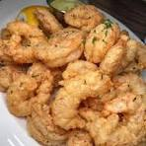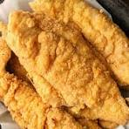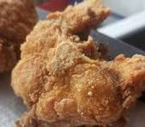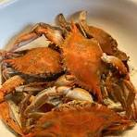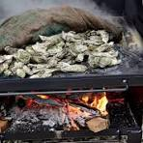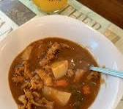

8:00-10:00p Conversation and Music/Clean up

Friday, July 10th, 2026

7:00a–UTC Breakfast on your own
(Until Complete)

12:00p-UTC Lunch on your own.
(Until Complete)

5:00-6:00p Scavenger Hunt Location: Starting Location
Bay Creek Park
Heritage Building
3706 Dock Site Road
Edisto Island, South Carolina 29438
6:00-7:00p
(Serve Food) Buffet: Chicken Wings, Swedish Meatballs, Barbeque Little Smokies, Vegetable Rolls, Yellow Rice, Mixed Vegetables, Potato Salad, and Dinner Rolls.
Food catered by: ??????
Photography by:  Ninety7frames
Opportunity (Please try to be in the area for photo opportunity)
7:30-8:30p Family Feud
8:30-10:30p Music provided by: DJ ?????? 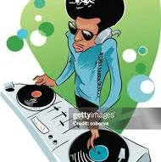
It’s the iconic “Soul Train Line” Get out there and strut your stuff!!!

10:30-11:00p Clean up

Saturday, July 11th, 2026

6:30-7:30a Breakfast on your own

8:00-11:00a PRIVATE AFRICAN AMERICAN JOURNEY- Botany Bay
Ecotours/Edisto Island Tour
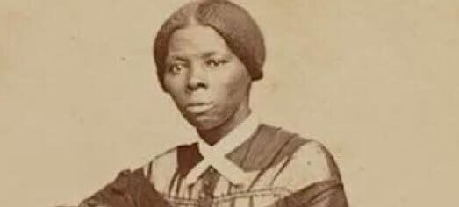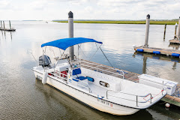
This tour of the waterways traveled by enslaved people who were active participants in gaining their freedom. We will uncover the links between the geography of the area and the history as we travel the rivers and creeks that served as transportation routes for centuries.

Botany Bay Ecotours partnered with Author Greg Esteves to create this tour based on his book “Edisto Island: The African American Journey.” Learn the previously untold stories of historic heroes from Edisto and the ACE Basin. Get on the waterways traveled by enslaved people who were active participants in gaining their freedom. We will uncover the links between the geography of the area and the history as we travel the rivers and creeks that served as transportation routes. Learn about Gullah/Geechee culture and what it is like today on the island.

Cost: $30.00 or Shared cost or Free pending proceeds.
Location:
Dock slip D 2, Edisto Marina
3702 Dock Site Rd
Edisto Beach, SC

Note: The boat can only hold up to 12 passengers at a time, we will have to schedule slots based on how many people are willing to go on the tour.

12:00p-UTC
(Until Complete) Lunch on your own
4:15-5:00p Youth Family Members Enlightenment
Host:
Volunteer Family Members
Location: Edisto Island Civic Center
42 Station Ct, Edisto Island, SC 29438

This is an opportunity I want us to talk with the younger generation about opportunities, making connections and enlightenment. And to answer questions they may have, this will be open to all, but I want to really reach the Middle School aged through college age family members.
I would like for any family member to Identify themselves and occupation if they want to participate, rather you are a doctor, lawyer military, hospitality, agriculture, Self Employed, Hotel/Motel Restaurant, Construction, Computers, Fast Food, Truck Driver, Secretary, Local, State, or Federal Government Employee, Nursing, etc...

5:00-6:00p
(Serve Food) Family BBQ Picnic (Wear T-Shirts)

Menu: BBQ Chicken, BBQ Ribs, Baked Beans, Green Beans, Corn on Cob, Red Rice, Dirty Rice, and Tossed Salad.

Food catered by: ???????

Location:
Edisto Island Civic Center
42 Station Ct, Edisto Island, SC 29438
6:00-7:00p Family Time “Power Hour”
7:00-8:00p Genealogy/Raffle Prizes/Auction/Family Meeting (All Please Attend)
Host: Kenneth Simmons

Location: Edisto Island Civic Center
42 Station Ct, Edisto Island, SC 29438

6:30-7:30p Photography by: Ninety7frames
Family Photo (All please attend)

8:00-11:00p  Live music provided by:
Beth Inabinett & For The Funk Of It
10:45-11:00p Clean up

Sunday, July 12th, 2026

10:00a-UTC 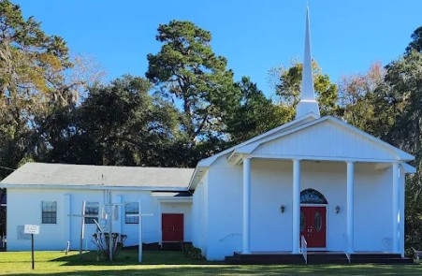

Following Church Services Huggs, Kisses and Handshakes
-Safe Travels and be careful.

Edisto Island Tour Information 2026

Who is Edisto Beach named after?
Edistow people
The island, the town, and the Edisto River are named after the historic Edistow people, a Native American sub-tribe of the Cusabo Indians, who inhabited the island as well as nearby mainland areas.

What is the history of Edisto?
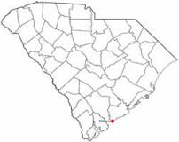
Edisto Beach was originally settled by the Edistow Indians but was rediscovered by the Spanish in the late 16th century.

1. Hutchinson House is the oldest identified house on Edisto Island, South Carolina associated with the black community after the American Civil War. It was the residence of Henry Hutchinson, a freedman who was a noteworthy post-war Sea Island Cotton planter.
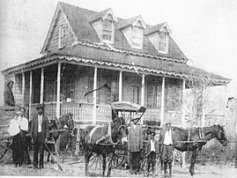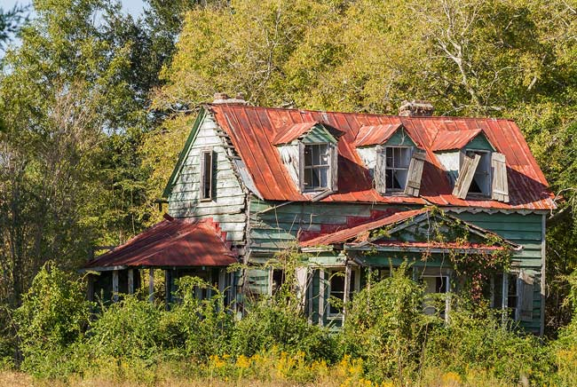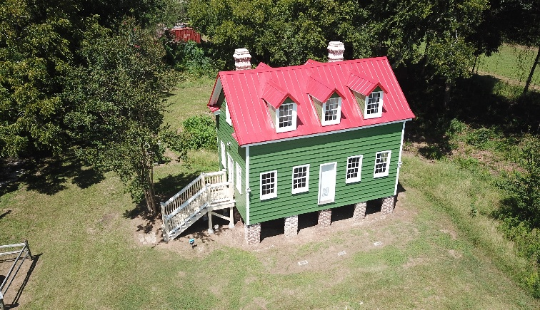
The Hutchinson House was originally constructed, circa 1900.
Jim Hutchinson's children built their own homes and farms on the land Jim had acquired. One of his children was Henry Hutchinson. Henry Hutchinson's house is the only one remaining.^{[2]} Henry Hutchinson is said to have built the house at the time of his marriage to Rosa Swinton in 1885 and resided here until his death in 1940.
The house was listed in the National Register of Historic Places in 1987.^{[5]} The house and property were purchased by the Edisto Island Open Land Trust, a local non-profit land conservation organization, in 2016.^{[6][7]}

2. Edisto Island Museum
8123 Chisolm Plantation Rd,(843)869-1954
T-Th-S 1-4 pm, Call for Summer hours: (843)869-1954
Exhibits of sea island plantation life, Civil War & Native American displays.
Admission Fee.

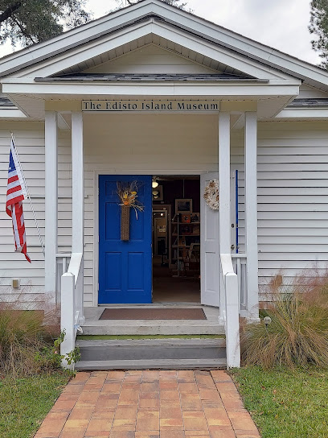

3. Old First Baptist Church
1644 SC Hwy 174, Edisto Island, (843)631-5040
This Church was founded and built in 1818 by the wife of an Edisto plantation owner, Hephzibah Jenkins Townsend. Many slaves worshiped here, and after the Civil War it was turned over to the African-American congregation. Descendants of 19th century members continue to worship today in the New First Baptist Missionary Church next door. The building is currently used by the Episcopal Church on Edisto…
now called African American New Missionary Baptist Church on Edisto Island is flooded by attendees from miles away every single Sunday. Today.
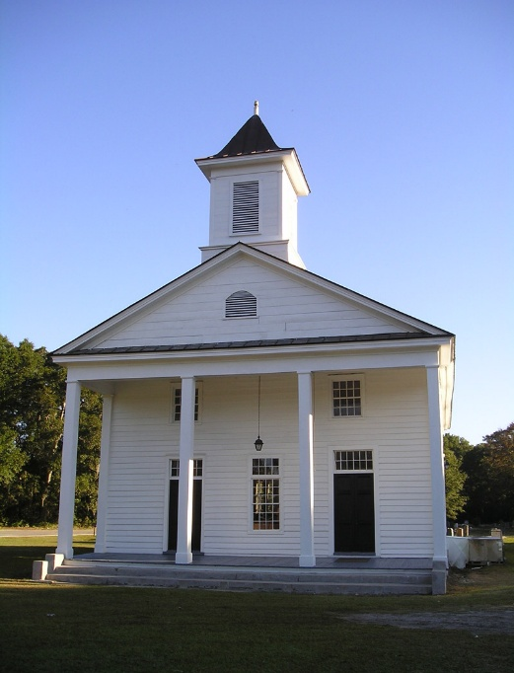

Hephzibah Jenkins Townsend and her ex-slave, Bella, baked cakes in tabby ovens, to raise enough money to build the Baptist Church. It is especially significant in Black History, because it has operated continuously as a black church since the trustees turned the church over to the faithful black members just after the Civil War.

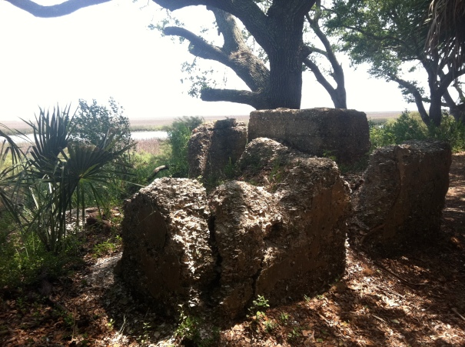

According to South Carolina Department of Archives and history “The Hephzibah Jenkins Townsend Tabby Oven Ruins are archaeologically significant. No other extant early nineteenth century tabby ovens have been inventoried in the South Carolina lowcountry. The remains represent what was essentially a commercial bakery. Historic documentation indicates the ruins are ovens which were constructed ca. 1815. The site consists of in situ tabby walls and foundations as well as portions of fallen walls and tabby rubble.

4. Seabrook Plantation – Edisto Island – Charleston County
Steamboat Creek Located about a mile west of SC 174 on Jenkins Road

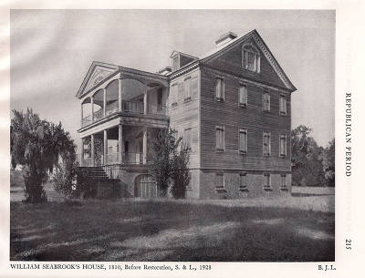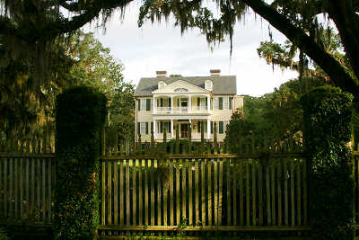

- Historic Antebellum 19th-century Slave Cabin on Point of Pines Plantation in Edisto Island, S.C.. Now in located in Washington DC at the Smithsonian National Museum of African American History and Culture. (32.56° N, -80.28° W. Coordinates: Approximately 32.5593516°N, -80.2950995°W (general Edisto Island area

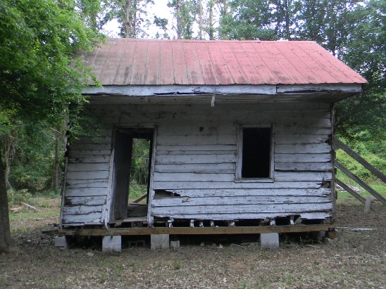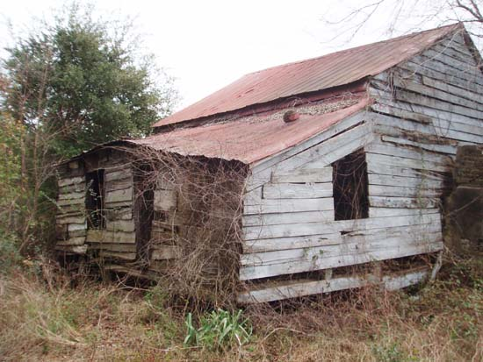
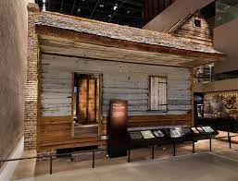

- Allen AME Church ( Burial Site of Harold James Simmons) 8060 Botany Bay Road Edisto Island, SC 29483

Advertisements and Information Page

